CONNECTED, LEVEL 2 2014, How Do You Know?  Super Senses  by Matt Comeskey  Overview  This article explores the amazing senses animals use to navigate the world, and it also explores how scientists gather and check evidence to form conclusions about their ideas.  A Google Slides version of this article is available at www.connected.tki.org.nz. |  |  | 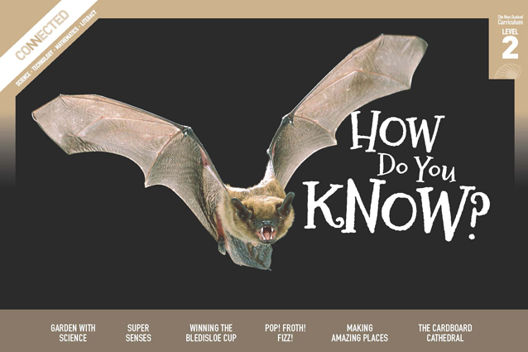  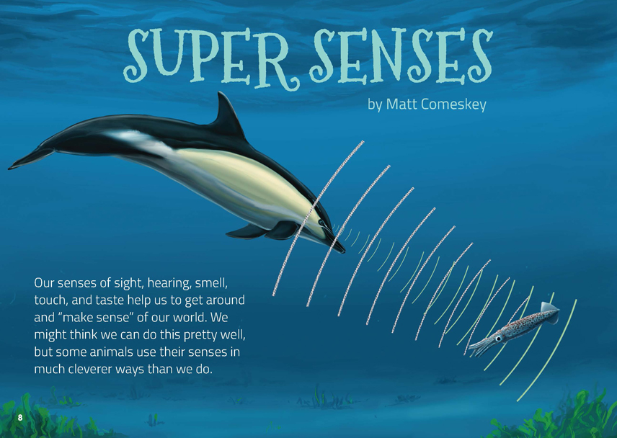
Science capability: Use evidence |  | Text characteristics

Science is a way of explaining the world. Science is empirical and measurable. This means that in science, explanations need to be supported by evidence that is based on, or derived from, observations of the natural world. Students should be encouraged to support their ideas with evidence and look for evidence that supports or contradicts other explanations. At the core of science is theory building – making better explanations. What sets scientific explanations apart from other ways of explaining the world is their reliance on evidence and their ability to evolve as new evidence comes to light.  For more information about the “Use evidence” science capability, go to http://scienceonline.tki.org.nz/Introducing-five-science-capabilities/Use-evidence |  | - A clearly structured article with headings that indicate the content in each section and help the reader to navigate the text.  - Conversational tone, including the use of idiom, that helps the reader to visualise information.  - Photographs and diagrams with captions that clarify the text and require some interpretation.  - Many subject-specific words with their meanings explained in the running text or in a glossary.

Curriculum context

SCIENCE
NATURE OF SCIENCE: Understanding about science  Achievement objective(s)  L2: Students will appreciate that scientists ask questions about our world that lead to investigations and that open-mindedness is important because there may be more than one explanation. |  | NATURE OF SCIENCE: Investigating in science  Achievement objective(s)  L2: Students will extend their experiences and personal explanations of the natural world through exploration, play, asking questions, and discussing simple models.  LIVING WORLD: Life processes  Achievement objective(s)  L2: Students will recognise that all living things have certain requirements so they can stay alive.  LIVING WORLD: Ecology  Achievement objective(s)  L2: Students will recognise that living things are suited to their particular habitat. |  | Key Nature of Science ideas  - Evidence is based on, or derived from, observations of the natural world.  - Scientific ideas and explanations are supported by evidence.  - Scientists make use of relevant evidence to support or revise their predictions and explanations  Key science idea  - Animals have different structural, physiological, and behavioural features that help them to survive.

ENGLISH

READING  Ideas  Students will show some understanding of ideas within, across, and beyond texts. |  | INDICATORS  - Uses their personal experience and world and literacy knowledge to make meaning from texts.  - Makes meaning of increasingly complex texts by identifying main ideas.  - Makes and supports inferences from texts with some independence. |  | THE LITERACY LEARNING PROGRESSIONS  The literacy knowledge and skills that students need to draw on by the end of year 4 are described in The Literacy Learning Progressions.

Using evidence

- Scientists use empirical evidence to develop theories about how the world works.
- Empirical evidence is data gathered from observations and experiments.
The science capability, Use evidence, is about students developing and considering theories and explanations in the light of evidence (http://scienceonline.tki.org.nz/Introducing-five-science-capabilities/Use-evidence).
Students should be:
- using evidence they have gathered to develop their own explanations about the way the world works
- critiquing explanations offered by others, including scientifically accepted explanations, by considering the evidence that supports them.
Scientific explanations, including those found in museums, in television programmes, on the Internet, and in non-fiction books and texts, often fail to discuss the evidence and testing that led to the development of these explanations.
Teachers can:
- help students to be more critical consumers of science information by being explicitly critical themselves
- model a sceptical stance
- ask questions such as:
  - How do you think people found that out?
  - What kind of evidence would support that idea?
  - How could a scientist test that idea?
- use concept cartoons to propose possible explanations. (See http://conceptcartoons.com/what-is-a-concept-cartoon-.html)
When doing practical investigations, teachers can support students to:
- consider a range of possible explanations for their findings
- think about how these explanations fit with the evidence they have gathered
- avoid suggesting that scientific investigations prove anything – rather, investigations provide evidence that supports or refutes a hypothesis or idea.
Establish a science classroom culture by:
- welcoming a range of possible explanations
- encouraging students to consider possible explanations in the light of evidence
- having students draw evidence from their experience
- using questions such as:
  - What have we seen today that supports X’s idea?
  - Has anyone seen anything somewhere else that might be evidence for X’s idea?
- encouraging investigation:
  - What could we do to test X’s idea?
  - What would we expect to happen? Why?
A range of questions and activities designed to get students to use evidence is available on the Science Online website: http://scienceonline.tki.org.nz/Introducing-five-science-capabilities/Use-evidence

Meeting the literacy challenges

The following instructional strategies will support students to understand, respond to, and think critically about the information and ideas in the text. After reading the text, support students to explore the key science ideas outlined in the following pages.

TEACHER resources

Want to know more about instructional strategies? Go to:
- http://literacyonline.tki.org.nz/Literacy-Online/Teacher-needs/Reviewed-resources/Reading/Comprehension/ELP-Years-1-4
- “Engaging Learners with Texts” (Chapter 5) from Effective Literacy Practice in Years 1 to 4 (Ministry of Education, 2003).
Want to know more about what literacy skills and knowledge your students need? Go to:
- http://literacyonline.tki.org.nz/Literacy-Online/Student-needs/National-Standards-Reading-and-Writing
- www.literacyprogressions.tki.org.nz/
“Working with Comprehension Strategies” (Chapter 5) from Teaching Reading Comprehension (Davis, 2007) gives comprehensive guidance for explicit strategy instruction in years 4–8.
Teaching Reading Comprehension Strategies: A Practical Classroom Guide (Cameron, 2009) provides information, resources, and tools for comprehension strategy instruction.

INSTRUCTIONAL STRATEGIES

FINDING THE MAIN IDEAS
MODEL how to make a connection to the title, using prior knowledge to predict what this story might be about.
- First, I need to think about what I know about the words “super” and “senses”. I know that I have five senses: sight, hearing, smell, touch, and taste. “Super” means that something is especially good, so a “super sense” must mean that an animal or person has an especially powerful sense.
Ask the students to check your predictions by SKIMMING the text and looking at the pictures.
- Do you think I was right? Whose senses are we going to find out about?
Activate the students' prior knowledge by DISCUSSING what they know about senses.
- When are you aware of your senses?
- Why do you think animals have senses?
MODEL how the students can create and use a graphic organiser to summarise how and why the animals in the article use their super senses. As the students read, use the graphic organiser to RECORD the main ideas.
Animal | Super sense | How they use their super sense | Why this super sense is important
Dolphin | Echolocation | To find objects underwater | Safe navigation, location of food

DEALING WITH UNFAMILAR VOCABULARY AND USING DIAGRAMS TO CLARIFY THE TEXT
IDENTIFY which words and phrases are less and more important for the students to know as they engage with the science/maths/technology ideas in the text.
EXPLAIN that many words in this text may be unfamiliar to them. Point out that some of these words are explained in the glossary, some in the text, and some in the images with their captions. Remind them to look for clues, either in the same sentence as the unfamiliar word, the sentence before, or the sentence after. Tell them that the diagrams may also provide clues.
Have them SCAN the text, identifying and recording vocabulary that is new. PROMPT them to use the supports in the text to unpack the meaning of the new words. If they find they are still unsure, encourage them to look in a dictionary or thesaurus.
After reading the first paragraph on page 9, DISCUSS how the illustration on page 8 shows how dolphins use echolocation. Reinforce the students' understandings of the words “echo” and “echolocation” by having them draw on their knowledge of the prefix “echo” and the suffix “location”. Use the dictionary to find words from the same word family (for example, “echosounder”, “echogram”, “echograph”). DISCUSS the relationship between these words, drawing out the idea that we can use our understandings of a familiar word to work out the meanings of new words.
Try the activity on page 9 and DISCUSS the concept of clicking as a way of seeing.
DISCUSS how a dog can tell the direction someone has gone by smelling just five of their footsteps. Ask: How might scientists “know” this? Have the students use information from the text to sketch a diagram explaining this. Compare their diagrams, checking their clarity.
Ask the students to IDENTIFY the colloquial words and terms that give this article its conversational tone. ASK QUESTIONS to help them consider why the author chose this tone and whether they think it was a good decision.
- Why does the author use these everyday terms?
- Do you like the effect? Why?

Key science ideas
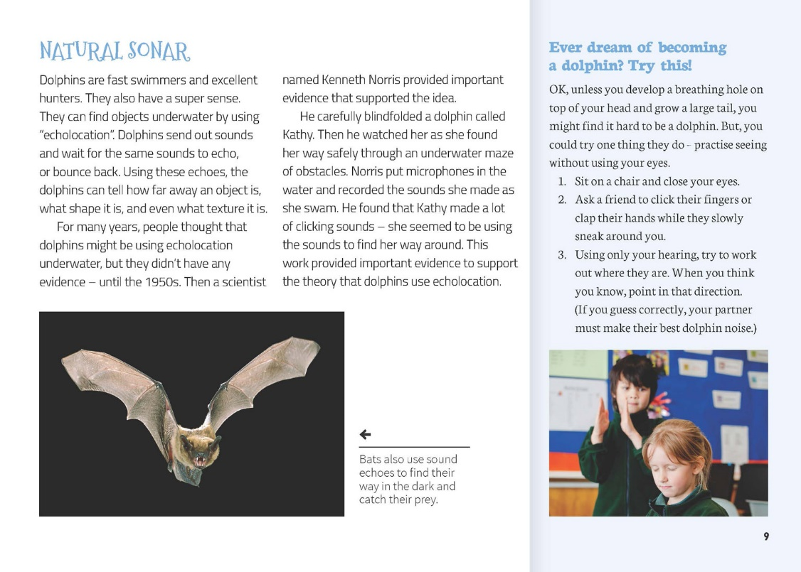 | Observations provide evidence that can be used to support or revise ideas.  Students extend their experiences through exploration.  Dolphins and bats have structural features that help them to survive.  Students extend their experiences through exploration.
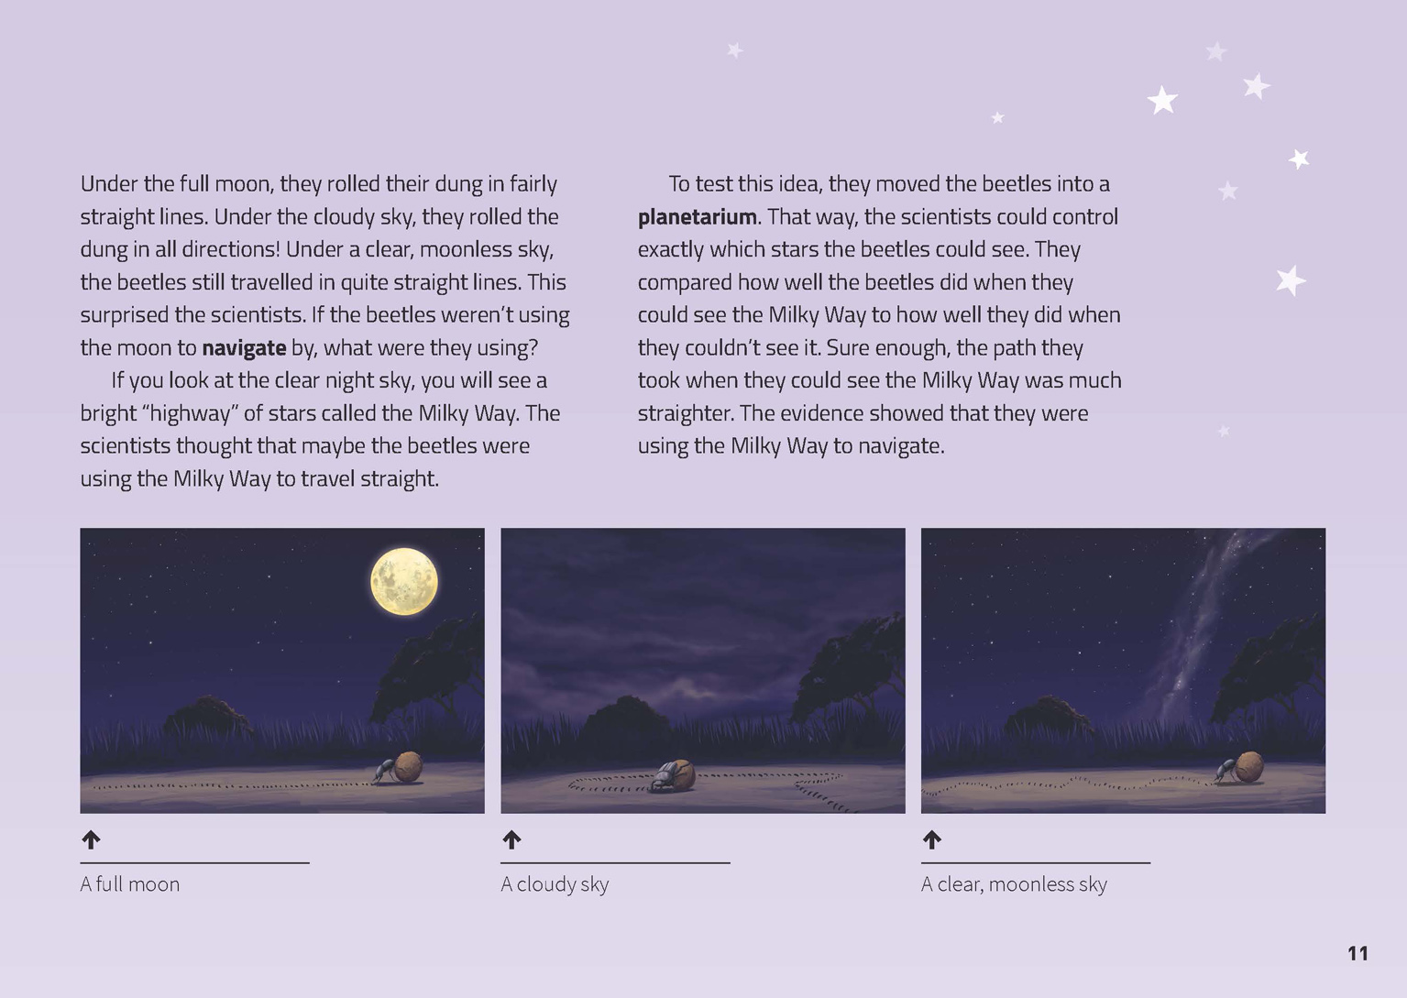 | Evidence is based on observations of the natural world.  Scientific ideas are supported by evidence.  Scientists ask questions about our world that lead to investigations.

Exploring the science
Some activities focus directly on the science capability of “using evidence to support ideas” and the Nature of Science strand. Other activities extend student content knowledge. You are encouraged to adapt these activities to make the focus on Nature of Science explicit and to support students to develop the capability of using evidence to support ideas.

LEARNING FOCUS
Scientists use evidence to support their ideas.

LEARNING ACTIVITIES

Activity 1: Animal sense
Look at the photographs of the animals in the article.
What are these animals?
What super senses do they have?
How can we find out?
Have the students visit the library or go online to research information about animals with super senses. Have them record this information on their graphic organiser (see Instructional Strategies section).

Animal | Super sense | How they use their super sense | Why this super sense is important

Help the students to collate the information and analyse it to draw conclusions. Draw out the idea that animals need their senses to survive – to find and eat food, avoid predators, and so on. Prompt students to research how scientists find evidence to support ideas. Then have them report their research on a poster. Each student could present their findings about one animal.
Extension
The students could investigate some of the ways animals in their own environment carry out other functions (for example, movement, eating).
What other functions do animals need to be able to perform to stay alive?
How do they perform these functions?
You may also like to discuss the idea that humans have found ways to take advantage of animals' special abilities. Dr. Joy Reidenberg concludes a TED Youth Talk on whales and echolocation by pointing out how discoveries from her work can be applied for the benefit of humans (http://ed.ted.com/lessons/how-whales-breathe-communicate-and-fart-with-their-faces-joy-reidenberg). We see an example with the sniffer dogs in the article – but did you know that dung beetles are also useful to humans? Successful trials show that dung beetles can be used to break up dung on New Zealand farms, reducing its impact on the soil and water.

Activity 2: Snail sense
Garden snails are an easy animal for students to investigate. They are readily found and move slowly, and because they are invertebrates, you aren’t required to obtain ethical approval. However, always ensure an ethical approach to any investigations. Students can quite easily investigate whether snails respond to light, sound, smell, or gravity. They can also observe carefully to gather evidence that tests their ideas about how snails move and eat. There are lots of ideas in Slugs and Snails: Investigating Small Animals, Building Science Concepts, book 45.
Animal adaptation – snail (LW 0637), from the Assessment Resource Bank (http://arb.nzcer.org.nz/resources/science/bsc.php), can be used to check student understanding.
Extension
You can also use working with snails or other small animals as a way of highlighting ethical and caring behaviours. Page 8 of Slugs and Snails: Investigating Small Animals suggests what you might say to the students about snails. The resource that it refers to, Caring for Animals: A Guide for Teachers, Early Childhood Educators, and Students, is now available on Science Online (http://scienceonline.tki.org.nz/Teaching-science/Ethics/Caring-for-Animals).

Activity 3: People sense
Follow the activity on page 9 of the article with other investigations into the students' senses. Science Rocks (see links below) has activities the students can use to:
test their peripheral vision
test their blind spots
test their reaction time
find out how important sight and smell is to the ability to identify foods.
Use these activities as a precursor to going deeper into one particular aspect. For example, the students could:
read the School Journal article “Mmm, That's Tasty!” to find out more about how the tongue works with other senses to help us decide whether we like particular foods
conduct the NASA activity that allows them to investigate how well the central nervous system can estimate a position based on information other than sight and sound (http://www.nasa.gov/pdf/544714main_Finding_Your_Way.pdf)
learn about the structure of the eye and how it works, as explained on the Science Learning Hub (see links below). The student activity “Pinhole Cameras and Eyes” describes how students can create their own working models of the human eye (http://www.sciencelearn.org.nz/Contexts/Light-and-Sight/Teaching-and-Learning-Approaches/Pinhole-cameras-and-eyes).
Google Slides version of “Super Senses” www.connected.tki.org.nz

RESOURCE LINKS

“Animal adaptation – snail (LW 0637)”. From the Assessment Resource Bank. http://arb.nzcer.org.nz/resources/science/bsc.php
Building Science Concepts, Book 45 – Slugs and Snails: Investigating Small Animals
“Caring for Animals: A Guide for Teachers, Early Childhood Educators, and Students”. From Science Online. http://scienceonline.tki.org.nz/Teaching-science/Ethics/Caring-for-Animals

School Journals
“Four Senses” by Briar McMahon. School Journal Part 1 Number 1, 2005, pp. 2–6.
“Mmm, That’s Tasty!” by Neville Gardner. School Journal, Level 3, June 2012, pp. 25–29.

Science Learning Hub
“Crabs Finding Home” www.sciencelearn.org.nz/Contexts/The-Noisy-Reef/NZ-Research/Crabs-finding-home
“Depth Perception” (Binocular and monocular vision explained). www.sciencelearn.org.nz/Contexts/Light-and-Sight/Science-Ideas-and-Concepts/Depth-perception
“Light and Sight” www.sciencelearn.org.nz/Contexts/Light-and-Sight
“How the Eye Works” www.sciencelearn.org.nz/Contexts/Light-and-Sight/Sci-Media/Video/How-the-eye-works
“How the Eye Focuses Light” www.sciencelearn.org.nz/Contexts/Light-and-Sight/Science-Ideas-and-Concepts/How-the-eye-focuses-light
“How We See 3D” www.sciencelearn.org.nz/Contexts/Light-and-Sight/Sci-Media/Video/How-we-see-3D
“Non-visual Sensory Systems of Fish” www.sciencelearn.org.nz/Contexts/The-Noisy-Reef/NZ-Research/Non-visual-sensory-systems-of-fish
“Student activity – Pinhole Cameras and Eyes” www.sciencelearn.org.nz/Contexts/Light-and-Sight/Teaching-and-Learning-Approaches/Pinhole-cameras-and-eyes
“Student Activity – Sound Detectives” www.sciencelearn.org.nz/Contexts/The-Noisy-Reef/Teaching-and-Learning-Approaches/Sound-detectives

Other resources
Dung Beetles in New Zealand www.nzherald.co.nz/nz/news/article.cfm?c_id=1&objectid=11130558
http://dungbeetle.org.nz/release-programme/
“How Whales Breathe, Communicate … and Fart with their Faces” from TED-Ed
http://ed.ted.com/lessons/how-whales-breathe-communicate-and-fart-with-their-faces-joy-reidenberg
“Learning Activity 1: Finding Your Way around without Visual or Sound Cues” from NASA www.nasa.gov/pdf/544714main_Finding_Your_Way.pdf
Science rocks! From ZoomSci, PBS Kids
“Clapping? Where?” (Echo-location). http://pbskids.org/zoom/activities/sci/clappingwhere.html
“Peripheral vision” http://pbskids.org/zoom/activities/sci/peripheralvision.html
“Reaction time” http://pbskids.org/zoom/activities/sci/reactiontime.html
“Taste V. smell” http://pbskids.org/zoom/activities/sci/tastevsmell.html
“Blind spot” http://pbskids.org/zoom/activities/sci/blindspot.html

